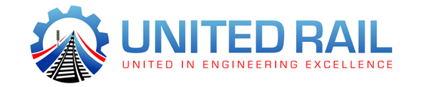
Staff Safety Responsibility Statement

The following Safety Responsibility Statement applies to all United Rail Ltd.
Staff/contractors who will carry out work on or about Network Rail Managed Infrastructure.
You are required at all times to ensure avoidance of injury to yourself and colleagues and to minimise risk to the environment, railway infrastructure and the travelling public.
When working near the public, you must at all times ensure that the passengers have a clear and safe walking route. If this cannot be achieved, then all work must stop until the situation is rectified.
You must not start any work on Network Rail Managed Infrastructure if there is any possibility that the works may over-run the agreed timescales.
You are required to demonstrate a positive and encouraging attitude towards health and safety at all times.
You must ensure that all PPE provided is cared for and used when required.
You are required to report all accidents, incidents and near-misses.
You are expected to participate in accident and incident investigations.
You are expected to participate and input into regular safety briefings, toolbox talks and other meetings when required
You must not start any work activity until you have been briefed on and understand the method of work, site-specific risks, local hazards, the safe system of work and emergency arrangements.
You must be briefed on the Work Package Plans and be provided with a copy of the Task Briefing Sheet for all work on Network Rail Managed Infrastructure.
You must ensure you work to the sections of the Rule Book GE/RT8000 that are relevant to your duties.
Only access rail infrastructure through access points, and where practicable use authorised walking routes.
Follow and work to the instructions given by the Controller of Site Safety (COSS) or Safe Work Leader (SWL).
Always leave the worksite clean, tidy and free from hazards.

Name:

Signature:

Date:

